Stored Procedures and Functions

1.Create a procedure to accept an empno as a input parameter and display the detail like ename,sal and deptno.
.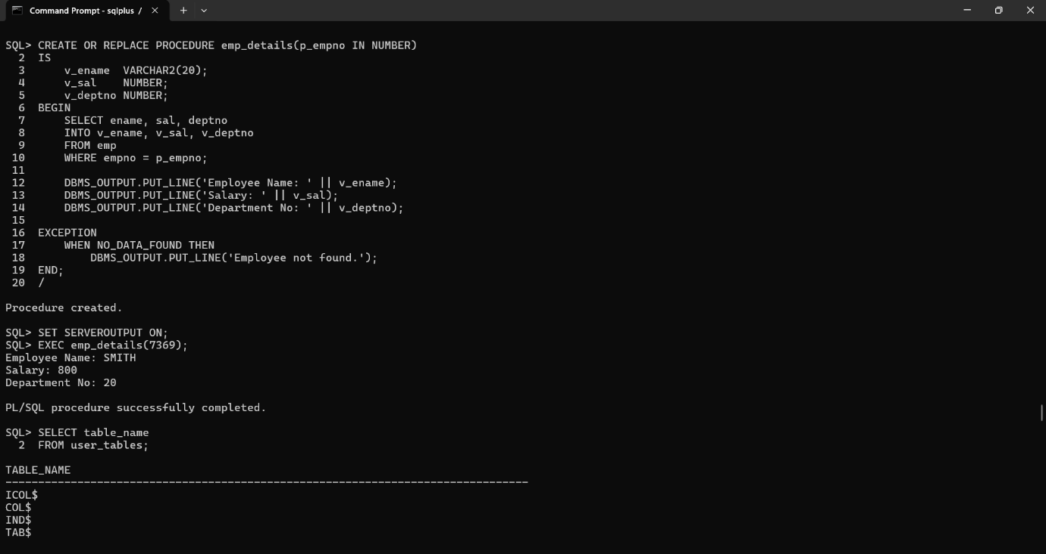
2.Create a function called Add_Num() that accept two paraemter of number type and return the addition result in number type.
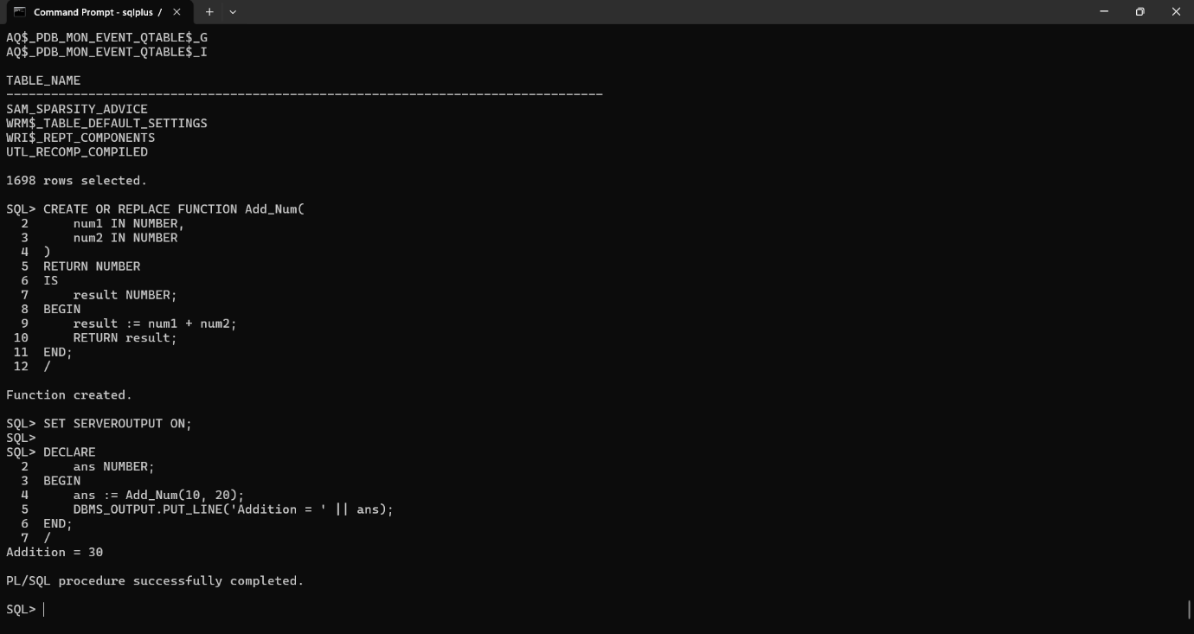

3.Create a procedure that will display all the names list of procedures and functions from the current schema by querying user_source table with the help of cursor.
